Background will be mapbox of Dhaka’s Map - Try out little bit of zoom in zoom out camera movement when different tracks come into view but the lighthouse score and lag time will determine the final outcome - if the lighthouse score is less than 90 or it takes time to load the map tiles - camera movement and zoom in out will be opted out. Images here are for context only - the whole scrolly will happen on top of the map

- Hero section: The Daily Star’s logo on the top left corner - sticky

Working Title: Dhaka's Metro Lifeline and Its Ballooning Price Tag(Centered on the screen)
After the first scroll it will go away and then the visual effect - The MRT6 line with the train navigating its length.

Visual with the working title: The MRT6 line with the train navigating its length.

- After another scroll the text box will come(the text boxes will come from the bottom and will go all the way top with scrolling and when it reaches the top it will fade away - giving way to the next text box

Visual continues: The MRT6 line with the train navigating its length.

Text: In 2005, the government and the World Bank formulated a 20-year Strategic Transport Plan that recommended mass rapid transit (MRT) corridors. Approved by the government in 2016, the Revised Strategic Transport Plan (RSTP 2015–2035) establishes a comprehensive urban transit blueprint initially proposing five Mass Rapid Transit (MRT) lines and two Bus Rapid Transit (BRT) lines—later expanded by DMTCL to six MRT lines spanning over 100 stations.The Executive Committee of the National Economic Council (ECNEC) formally approved the MRT Line-6 project with Japan's JICA in 2012.
(Delay of about 2 seconds)

After another scroll

Text: The initial cost of the project was slated to be Tk 21,985 crore at inception. By the end, when the line was inaugurated in 2022, the costs had escalated to Tk 33,472 crore, a rise of 52.25 percent.

- After another scroll

Same visual but with an added station

Text: One station is yet to be added to the MRT 6 line. This station will be added by early 2027.
The station will be at Kamlapur. At the moment, nearly 80 percent (77.2%) of its construction is complete.

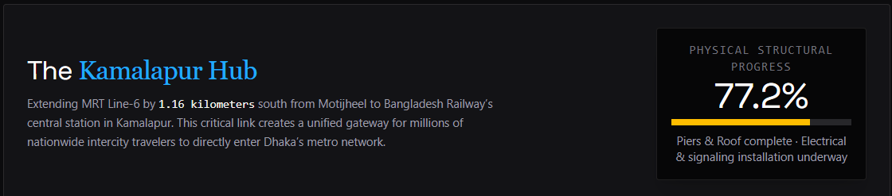

- After another scroll

Visual: The MRT6 line with the train navigating its length. Two new lines appear – Line 1 and Line 5N
After another scroll

Text: Line-1 and Line 5N were approved on October 15, 2019 for a combined cost of Tk 2,13,984 crore.

After another scroll

Line 1 has a 19.87km underground section connecting Dhaka airport with Kamalapur, and an 11.37km elevated section from Natunbazar to Pitalganj Depot in Narayanganj, while Line-5N runs from Hemayetpur to Bhatara.

After another scroll

- Text: On Wednesday, October 15, the ECNEC revised the cost of the lines and put them at Tk 2,03,800 crore, an increase of 117 percent.

After another scroll

Text: Line-1 & 5N will be Bangladesh’s first Underground Rail Projects. While Line-6 rides on elevated concrete piers above the city streets, 12 of the 21 stations of MRT Line-1, and 9 out of 14 stations of MRT Line-5 North will be subterranean. MRT Line-1 will be the country’s first subway.

- After another scroll

Visual: MRT Line 5S gets added to the network.

Text: On the same day (Wednesday), ECNEC approved MRT Line-5 Southern. The project has an estimated cost of Tk45,503 crore, a reduction of about 16.7% from its April 2024 estimate. MRT Line 5 (Southern) was approved with loan assistance from the ADB and South Korea at BDT 45,504 crore,

After another scroll

The project will run from this month to August 2033. More than two-thirds of the 17.2km line will be underground. MRT Line 5 (Southern Route) spans a total length of 17.4 km—comprising 12.8 km underground and 4.6 km elevated—connecting Gabtoli in the west to Dasherkandi in the east while passing through major central areas including Shyamoli, Asad Gate, Karwan Bazar, Hatirjheel, Tejgaon, and Aftabnagar.

- After another scroll - the map will settle and show all the lines and will become clickable

Visual: The full network, clickable and interactive(the Re-Engineering Dhaka’s Geography’s visual)
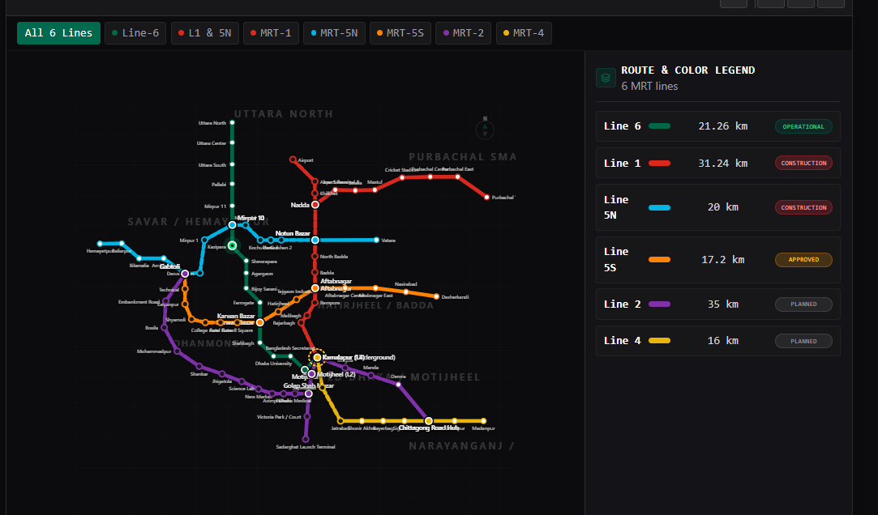

Text: When completed, the full metro network will look like this.

- Then after another scroll the map will not be pinned anymore and another section will begin with a centered text

Text: The Dhaka Mass Transit Company Limited (DMTCL) is planning a fresh timeline for developing five additional metro rail corridors in the megacity, after a lapse of over a year, as the current target of completing all Mass Rapid Transit (MRT) lines by 2030 was never considered realistic.

Officials indicated that the earlier target of completing all MRT lines by 2030 is now unlikely to be met, with a revised completion date likely around 2035.

Visual: A timeline with all the significant years and dates. Don’t make the timeline clickable - instead of popups, have labels.

Then the footer with The daily star logo on the left bottom corner and on the right the social media icons

